**Lab Exercise 3**

**Create a Pull Request in Git**



Steps to be followed:

1. Create a Fork
2. Clone your Fork
3. Sync fork with the original repository
4. Push your Changes
5. Create a Pull Request

**Step 1: Create a Fork**

1.1 Login to your Github account.

1.2 From your browser navigate to the following repository **https://github.com/GithubResources1/Source-repository.git**

1.3 In the top-right corner of the page, click the **Fork** button

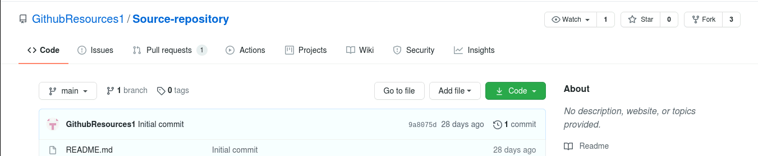

**Step 2: Clone your Fork**2.1 On GitHub, click on the **code** button on your repository

2.2 Copy the URL from under Clone with HTTPS option

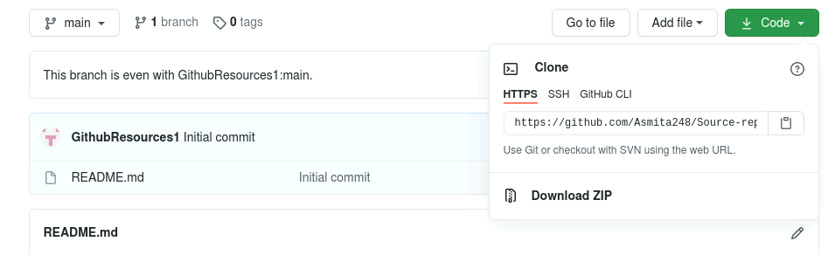

2.3 Type the following command on your terminal:

**git clone [the copied HTTPS URL]**

**Note:** Replace [the copied HTTPS URL] in the above command with the URL you copied from the Github page. The final command should look like the following:

***git clone https://github.com/Asmita248/Source-repository.git***

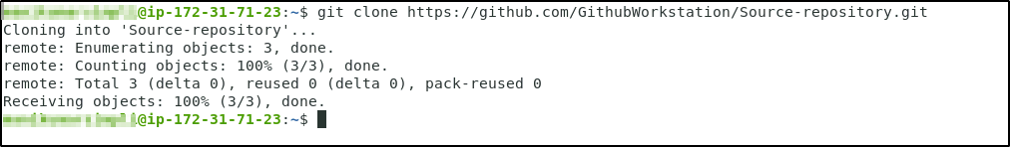

2.4 The **clone**command creates a local git repository from your remote fork on GitHub.

**Step 3: Sync fork with the original repository**

3.1 Navigate to the directory where the fork has been cloned using the following command in the terminal:

***cd Source-repository***

3.2 Use the following command to see the configured remote repository for your fork:

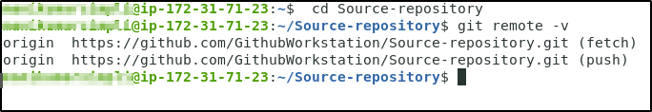

***git remote -v***

3.3 Use **git remote add upstream** command, and paste the URL you copied in Step 2 as shown below:

**git remote add upstream [the copied HTTPS URL]**

3.4 Use the following command to verify the new upstream repository you have specified for your fork:

***git remote -v***

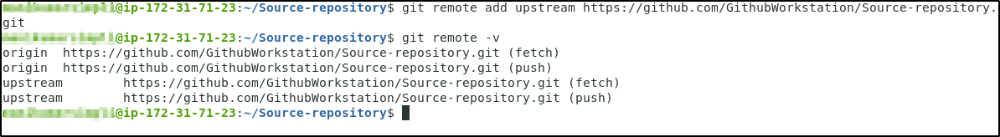

**Step 4: Push your Changes**

4.1 Use the **git push** command to upload your changes to your remote fork on GitHub:

***git push***

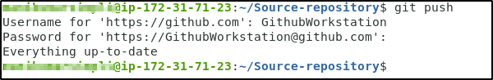

**Step 5: Create a Pull Request**

5.1 On the GitHub page of your remote fork, click the **pull request** button

5.2 Wait for the owner to merge or comment on your changes

5.3 If the owner suggests some changes before merging, you can simply push these changes into your fork by repeating steps 3 and 4, and the pull request is updated automatically.

